**Project Proposal (Sample Outline)**

The finished project must demonstrate your mastery of building a responsive, valid html and CSS website that makes appropriate use of JavaScript and/or JQuery along with data from JSON file(s). Usability concepts to meet the needs of users and design principles to enhance the appearance of the web site are also expected.

Each section of the proposal should be thorough in its descriptions. If done well, the proposal becomes a blueprint for you to follow as you develop your project. Most proposals are between 3 – 5 pages.

**Project Purpose**

This project will be a website all about information about the key story of Dragonball Z. Its purpose will be to be designed to include information, pictures to add images to the characters and story. Plus it will explain what games are out there for Dragonball Z. Overall it is a one stop place to look at a good summary and explanation of all things Dragonball Z. The purpose will be a good introduction to those who may not know it. Separate pages for characters, the storylines of Dragonball Z, and games they can buy if they don’t want to watch the entire series.

**The Audience**

The audience are individuals who have maybe heard about Dragonball Z from those older than them. The main age consensus would most likely be people around 13-20 year olds. A great deal of people who have ever heard of japan Animation or Anime know about the impact of Dragonball Z on all kinds of mediums in Japan as a whole. I hope to be able to adequately educate them with a good but reasonable sized summary.

**Web Pages**

Provide a list of all the web pages you will need to build your project.

Provide the name of each and a description of what it will do in the project - the more detailed the better.

You could organize the items by content area or function to demonstrate relationships of pages to one another. A site diagram, while not required, could be useful (example - <https://belindapullicino.files.wordpress.com/2011/06/picture-1.png>).

Index page- Explains the purpose of the website and a fun dragonball Z picture to attract attention. Will mainly be for navigation purposes. (The main color scheme will be Black, red, and white)  
  
Character page – A page with the main characters of Dragonball Z where you can see a small summary of each main character. I want to do this for the json file. Create a json object for each character and use a function to bring it out depending on which character they choose. (If they choose a character, it will open a function in javascript that will have an if loop that will look at which character they clicked on and then output whatever one they clicked on.

Summary page – This page will be a main summary of the Dragonball Z storyline with the world. There will be a link to another page that briefly describes a (what you should know about Dragonball, the series that takes place before Dragonball Z)

Games page- A short description of games that would help explain the story and what systems you could buy them on. Or just to watch youtube cinematics if you aren’t a gamer and want a bit more detail on the series that isn’t covered in this summary.  
  
Storyline Arcs page – This will be a bit more depth of the story based on a storyline arc by arc description.

**Wireframe Sketches**

Choose a typical content page and develop a wireframe sketch of it for small, medium and large screens. You can use the templates provided in week 4. Be sure to add enough detail to guide you later as you actually build the page to know where the various content and page pieces will be placed and approximate sizing. Keep in mind the PARC principles as you develop your sketches.

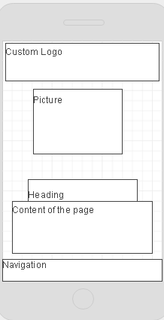

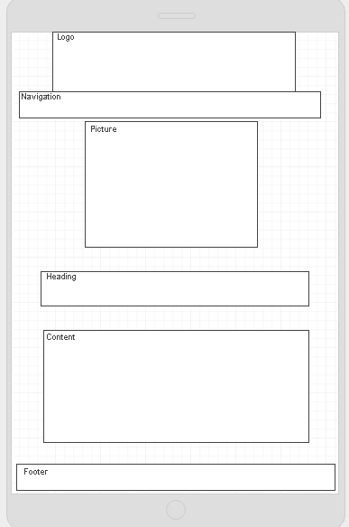

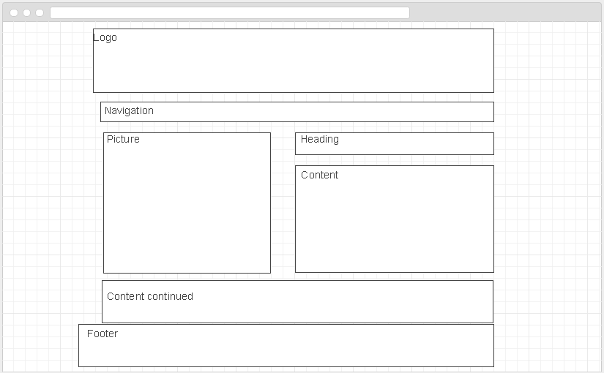

**Usability Concepts**

Refer to the Usability checklist (available in week 8) for 25 common usability factors to include in web pages. Remember that the items highlighted in yellow are “low hanging fruit” or the items that can be the most easily done and provide the most return to users. Describe how you will implement items from the checklist into your web pages to increase their usability.

This item will have a flex-format of column for mobile and tablets and then switch to row for the large screen size. This will make it easier to read and manage for users. The links for navigation are going to only be directed toward the pages outside the home page as the logo will be a link all in itself to the home page. Overall it will be a clean and straight forward layout.